Assignment 2

**Q.1. What is involved in project scope management, and why is good project scope management so important on IT projects?**

Project scope management contains processes which defines and control what work is or is not included in a project. There are total six processes are involved

1. Planning scope management 2. Collecting requirements

3. Defining scope

4. Creating the WBS

5. Validating scope

6. Controlling scope

Most IT engineers are involved in project work, so it is very important to understand basic concepts of project management to help projects succeed. There is change in requirements in IT industry. As requirement changes the time taken to complete one project is delayed. Also if we give more time on one project we can overspend in the budget of the project. Hence we have to increase the budget. Also we have to meet deadlines .so proper planning is required in IT field. To overcome these problems good scope project management is required in the IT industry. By deriving a clear scope for the project, managers can easily ensure that all deadlines are followed throughout the project life cycle.

**Q 2. What is involved in collecting requirements for a project? Why is it often such a difficult thing to do.**

Collecting requirement includes documenting and defining the features and functions from the project from stakeholders and the customers. Basically it collects the data of need of the customers and stakeholders. Requirements are collected by various methods such as taking interviews of the people. It is very effective. We can achieve it by holding host groups, workshops, decision making techniques the process will be faster and also so effective.one to one questions and surveys are also more accurate methods. Observation is also best technique for collecting requirements from the customers. For many software projects, prototyping and document analysis are techniques for collecting requirements.

Collecting requirement is difficult thing to do because Even though there are many ways to collect requirements, people who work on software projects in particular have considerable difficulty in defining and managing requirements. The important task for their teams was gaining a clear understanding of what customers wanted and further documenting and managing requirements. 83 % percent of software development teams still use Microsoft Office applications such as Word and Excel as their main tools to communicate requirements.

**Q.3 Discuss the process of defining project scope in more detail as a project progresses, going from information in a project charter to a project scope statement, WBS, and WBS dictionary.**

The project charter is the important document that officially authorizes a project. It provides the project manager the authority to apply organizational resources to project activities. Before planning begins, the project manager should be appointed while the project charter is being developed. A project manager is identified and appointed as early in the project as possible. The project charter describes the high-level scope, time, and cost goals Its helpful document for other scope related information, such as the project boundaries, constraints, and assumptions.

As time passes, the scope of a project should become clear and specific to the point and it should contain at least product scope description, product user acceptance criteria, and detailed information on all project deliverables. Most of IT projects want detailed functional and design specifications for developing software. The team must update the scope statement. Up to date project scope statement is an important document for confirming a common understanding of the project scope. After scope, project manager should create WBS. A work breakdown structure (WBS) is planning tool to help team for grouping deliverables of the work involved in a project that describes total scope. It is also important to organize and divide the work into logical parts based on how the work will be performed. The WBS is a basic document in project management because it provides the basis for planning and managing project schedules, costs, resources, and changes. It is very crucial to develop a complete WBS. A WBS dictionary is a document that provides enhanced information about each WBS item.

**Q4. Consider the following table. All duration estimates or estimated times are in days, and the network proceeds from Node 1 to Node 9.**

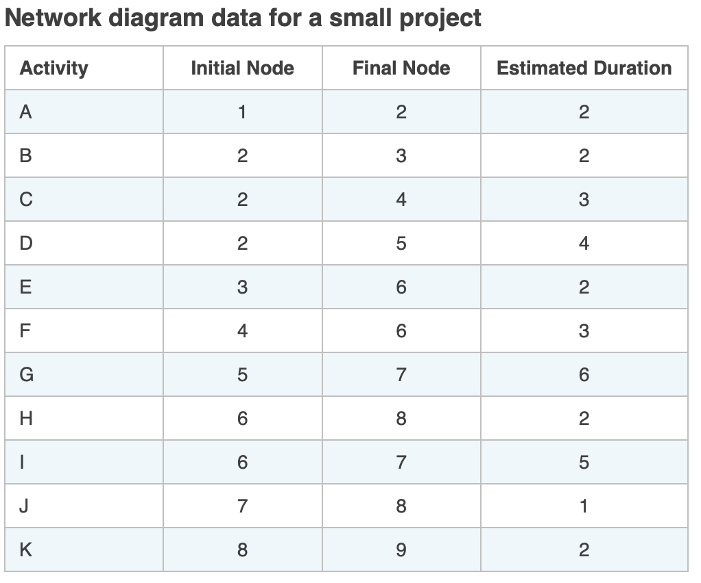

**a.Draw an activity-on-arrow (AOA) network diagram representing the project. Put the node numbers in circles and draw arrows from node to node, labeling each arrow with the activity letter and estimated time.**

**Answer:**

**b. Identify all of the paths on the network diagram and note how long they are, using Figure 6-8 (also available in the slide deck) as a guide for how to represent each path.**

**Answer :**

Path 1: A-B-E-H-K Length = 2+2+2+2+2 = 10 days

Path 2: A-C-F-H-K Length = 2+3+3+2+2 = 12 days

Path 3: A-C-F-I-J-K Length = 2+3+3+5+1+2 = 16 days

Path 4: A-D-G-J-K Length = 2+4+6+1+2 = 15 days

**c. What is the critical path for this project and how long is it? What is the shortest possible time needed to complete this project?**

**Answer:**

Critical path is the longest path through the network diagram,

Path 3, A-C-F-I-J-K, length is 16 days

This is critical path for this Small Project.

Path 1, A-B-E-H-K, length is 10 days,

This path is the shortest possible time taken to complete this Small Project.